Investering eksamen juni 2016

Exercixe 1
Q1
We determine the cashflows for each bond assuming a face value of 100
Annuity:
Finding the
$$\left(\left(100·1.06-x\right)·1.06-x\right)·1.06-x=0$$
$⇕$ Ligningen løses for x vha. WordMat.
$$x=37,411$$

$$B_{1}=\left(\begin{matrix}37,411 & 37,411 & 37,411\end{matrix}\right)$$
Serial bond
1.
$$\frac{100}{3}+0.08·100≈41,333$$
2.
$$\frac{100}{3}+0.08·\left(100-\frac{100}{3}\right)≈38,667$$
3.
$$\frac{100}{3}+0.08·\frac{100}{3}=36$$
$$B_{2}=\left(\begin{matrix}41.333 & 38.667 & 36\end{matrix}\right)$$
Cupon bond
$$B_{3}=\left(\begin{matrix}10 & 10 & 110\end{matrix}\right)$$
Q2
This gives us the market:
$$B=\left(\begin{matrix}37.411 & 37.411 & 37.411 \\ 41.333 & 38.667 & 36 \\ 10 & 10 & 110\end{matrix}\right)$$
Yes the market is complete since B is invertible we know that $rank\left(B\right)=3=T$
Thus the market is complete
A complete market is a market where we can create any cashflow structure by combining bonds already in the market
Yes it changes if we get another annuity instead of the serial bond because then bond 1 and 3 will then not be linearly independent thus the rank of B’(the changed B) will no longer be 3 but 2$≠3=T$

Q3 im thinking that the effective interestrate is exactly the yield to maturity

$$P_{1}=37.411·\left(\frac{1}{1+0.0477}+\frac{1}{{\left(1+0.0477\right)}^{2}}+\frac{1}{{\left(1+0.0477\right)}^{3}}\right)≈102,32$$
$$P_{2}=\frac{41.333}{1+0.0471}+\frac{38.667}{{\left(1+0.0471\right)}^{2}}+\frac{1}{{\left(1+0.0471\right)}^{3}}·36≈106,098$$
$$P_{3}=\frac{10}{1.0579}+\frac{10}{{1.0579}^{2}}+\frac{110}{{1.0579}^{3}}≈111,297$$
This gives us the pricevector:
$$P=\left(\begin{aligned}102.32 \\ 106.098 \\ 111.297\end{aligned}\right)$$
We then find the discountfactors
$${\left(\begin{matrix}37.411 & 37.411 & 37.411 \\ 41.333 & 38.667 & 36 \\ 10 & 10 & 110\end{matrix}\right)}^{-1}\left(\begin{aligned}102.32 \\ 106.098 \\ 111.297\end{aligned}\right)≈\left(\begin{matrix}0,968 \\ 0,927 \\ 0,839\end{matrix}\right)=d>0$$
Da er markedet arbitragefrit og komplet da B er invertibel og $B^{-1}P=d>0$

Q4
We calculate the modified durations
B_1
$$D_{mod}^{1}=\frac{1}{102,3}·\frac{1}{1.0477} ·37.411·\left(\frac{1}{1+0.0477}+\frac{2}{{\left(1+0.0477\right)}^{2}}+\frac{3}{{\left(1+0.0477\right)}^{3}}\right)≈1,88$$
B_2

$D_{mod}^{2}=\left(\frac{41.333}{1+0.0471}+\frac{38.667·2}{{\left(1+0.0471\right)}^{2}}+\frac{1·3}{{\left(1+0.0471\right)}^{3}}·36\right)·\frac{1}{106,098}·\frac{1}{1.0471} ≈1,837$

B_3
$$D_{mod}^{3}=\left(\frac{10}{1.0579}+\frac{2·10}{{1.0579}^{2}}+\frac{3·110}{{1.0579}^{3}}\right)·\frac{1}{111,297}·\frac{1}{1.0579}≈2,599$$

Q5 approximations we ignore accured interest since this seems to be intention of the assignment

$$ΔP≈P·-D_{mod}·Δλ$$
B_1
$$ΔP=102.32·-1.88·0.01≈-1,924$$
Thus the range I approximately
$$102.32-1.924≈100,396$$
$$102.32+1.924=104,244$$
$$P±-1.924⇒P_{1}^{next year}∈[100.396, 104.244]$$

B_2
$$ΔP=106.098·-1,837 ·0.01≈-1,949$$
$$106.098-1,949=104,149$$
$$106.098+1,949=108,047$$
$$P_{2}^{nextyear}∈[104,149, 108,047]$$
B_3
$$ΔP=111.297·-2,599·0.01≈-2,893$$
$$111.297-2,893=108,404$$
$$111.297+2,893=114,19$$
$$P_{3}^{nextyear}∈[108.404, 114.19]$$

Q6
He is right that it is the one that has the highest return but it is also the asset that is going to be more volatile because of its higher duration, since he wants it as a storage only for the next year, if we see a spike in interestrates he will end up loosing more on the bond with higher duration, assuming he wants a certain return a combination paying out only after the first period would be preferred but, if he wants this

He is right it has the best rate but it also has the highest duration which in this case basically means risk, assuming he just wants a place to store his wealth for a year and needs it after he would probably want the asset with the lowest risk instead
So he is right but might also just end up loosing money if rates suddenly spike

Q7
$$S_{0}=d_{2}=0.927$$
$$F_{1}=\frac{S_{0}}{d_{1}}=\frac{d_{2}}{d_{1}}=\frac{0.927}{0,968}≈0,958$$
it is the forwardrate that it represents or exactly the amount you need to pay at time 1 to get exactly 1 at time 2 if you agree to it at this moment
$$\frac{d_{2}}{d_{1}}=d_{1,2}=\frac{1}{1+f_{1,2}}$$

Exercise 2
Q1
$$dS_{t}=μ·S_{t} dt+σS_{t} dw_{t}$$
$$F\left(S_{t}\right)=\log\left(S_{t}\right)$$
Using itos lemma
$$dF=\left(μ·S_{t}·\frac{1}{S_{t}}+\frac{1}{2}·σ^{2}·S_{t}^{2}·-\frac{1}{S_{t}^{2}}\right)dt+σ·S_{t}·\frac{1}{S_{t}} dW_{t}=\left(μ-\frac{1}{2}σ^{2}\right)dt+σ dw_{t}$$
Q2
Girsanovs theorem says that we can simply switch measures from the physical to the risk neutral one by:
$$dW_{t}^{Q}=dW_{t}+\frac{μ-r}{σ}dt⇔dW_{t}=dW_{t}^{Q}-\frac{μ-r}{σ}dt$$
So under Q
$$dF=\left(μ-\frac{1}{2}σ^{2}\right)dt+σ \left(dW_{t}^{Q}-\frac{μ-r}{σ}dt\right)=\left(r-\frac{1}{2}σ^{2}\right)dt+σ dW_{t}^{Q}$$
Saying that we are at time 0
By properties of the SDE
$$F\left(T\right)=F\left(0\right)+\int_{0}^{T}{r-\frac{1}{2}σ^{2}}dt+\int_{0}^{T}{σ}dW_{t}^{Q}$$
$$=F\left(0\right)+T\left(r-\frac{1}{2}σ^{2}\right)+σW_{T}$$
Where W_T is $N(0,T)$
$$F{\left(T\right)}^{Q}\sim N\left(F\left(0\right)+T\left(r-\frac{1}{2}σ^{2}\right),σ^{2}T\right)$$
F(T) is normal with mean $F\left(0\right)+T(r-\frac{1}{2}σ^{2})$ and variance. $σ^{2}T$
Q3
At time T we will have
$$F{\left(T\right)}^{Q}\sim N\left(F\left(t\right)+\left(T-t\right)\left(r-\frac{1}{2}σ^{2}\right),σ^{2}\left(T-t\right)\right)$$
We simply do risk neutral pricing
Since F(T) is normal we simply write it
$$e^{r(t-T)}E^{Q}\left[F\left(T\right)\right]=e^{r\left(t-T\right)}\left(F\left(t\right)+\left(T-t\right)\left(r-\frac{1}{2}σ^{2}\right)\right)=e^{r\left(t-T\right)}\left(\log\left(S_{t}\right)+\left(T-t\right)\left(r-\frac{1}{2}σ^{2}\right)\right)=D$$
We call it D for derivative price
Q4
The BSM equation
$$r·D=\frac{∂D}{∂t}+r·S_{t}·\frac{∂D}{∂S_{t}}+\frac{1}{2}σ^{2}S^{2}·\frac{∂^{2}D}{∂S_{t}^{2}}$$
$$\frac{∂D}{∂t}=r·e^{r(t-T)}·\log\left(S_{t}\right)-\left(r-\frac{1}{2}σ^{2}\right)e^{r\left(t-T\right)}+r·\left(T-t\right)\left(r-\frac{1}{2}σ^{2}\right)e^{r\left(t-T\right)}=D·r-\left(r-\frac{1}{2}σ^{2}\right)e^{r\left(t-T\right)}$$
$$\frac{∂D}{∂S_{t}}=e^{r(t-T)}·\frac{1}{S_{t}}$$
$$\frac{∂^{2}D}{∂S_{t}^{2}}=e^{r(t-T)}·-\frac{1}{S_{t}^{2}}$$

$$D·r=r·e^{r\left(t-T\right)}\left(\log\left(S_{t}\right)+\left(T-t\right)\left(r-\frac{1}{2}σ^{2}\right)\right)$$
$$\frac{∂D}{∂t}+r·S_{t}·\frac{∂D}{∂S_{t}}+\frac{1}{2}σ^{2}S^{2}·\frac{∂^{2}D}{∂S_{t}^{2}}=r·D-\left(r-\frac{1}{2}σ^{2}\right)·e^{r\left(t-T\right)}+r·S_{t}·\frac{1}{S_{t}}·e^{r\left(t-T\right)}+σ^{2}·S_{t}^{2}·-\frac{1}{S_{t}^{2}}·e^{r\left(t-T\right)}$$
$$=r·D$$
Thus yes it satisfies the BSM equation
In the setting described ie constant risk free rate and underlying following a geometric brownian motion
$$no arbitrage⇒any derivativeprice satisfies the BSM equation$$
Thus if the derivative did not follow satisfy the BSM equation then there would be arbitrage in the market which is the thing we have build basically all our theory around not being

Exercise 3
We see that we have constant up and down rates and continous compounding
$$u=1.1, d=0.9$$
$$r=0.02$$
Q1

$$q=\frac{e^{r}-d}{u-d}=\frac{e^{0.02}-0.9}{1.1-0.9}≈0,6$$
$$1-q=1-0,6=0,4$$
Jeg afrunder til 0.6 og 0.4

Q2
Its a forward with forwardprice 100
We simply price it as such
$$v_{0}=s_{0}-Xd_{3}=100-100·e^{-3·0.02}≈5,824$$
Q3
We find the payoffs in each state
1.
$$133.1-105≈28,1$$
2.
$$108.9-105≈3,9$$

3.
$$89.1-95≈-5,9$$
4.
$$72.9-95≈-22,1$$
And then simply calculate the expectation under the risk neutral probability measure
$$e^{-3·0.02}(q^{3}·28.1+3·q^{2}·\left(1-q\right)·3.9+3·q·{\left(1-q\right)}^{2}·-5.9+{\left(1-q\right)}^{3}·-22.1)$$
$$=e^{-3·0.02}\left({0,6}^{3}·28.1+3·{0,6}^{2}·\left(1-0,6\right)·3.9+3·0,6·{\left(1-0,6\right)}^{2}·-5.9+{\left(1-0,6\right)}^{3}·-22.1\right)≈4,371$$

Q4
$$c_{0}=e^{-3·0.02}·\left({0.6}^{3}·33.1+3·{0.6}^{2}·0.4·8.9\right)≈10,354$$

Q5
We note (u is of course up from the stated state of the world)
$$c_{u}=8.9$$
$$c_{d}=0$$
$$s_{u}=108.9$$
$$s_{d}=89.1$$
We simply solve this system of equations
$$Δ·s_{u}+e^{0.02}·B=c_{u}$$
$$Δ·s_{d}+e^{0.02}·B=c_{d}$$

$$Δ·108.9+e^{0.02}·B=8.9$$
$$Δ·89.1+e^{0.02}·B=0$$
$⇕$
$$Δ=\frac{89}{198}≈0,449$$
$$B=-\left(\frac{11895329799}{303012020}\right)≈-39,257$$
Buy 0.45 of the asset and take a loan of 39.3 in the bank
Gives you the exact payoff of the option in the wanted period

Q6
In this assignment ill denote without time indexation
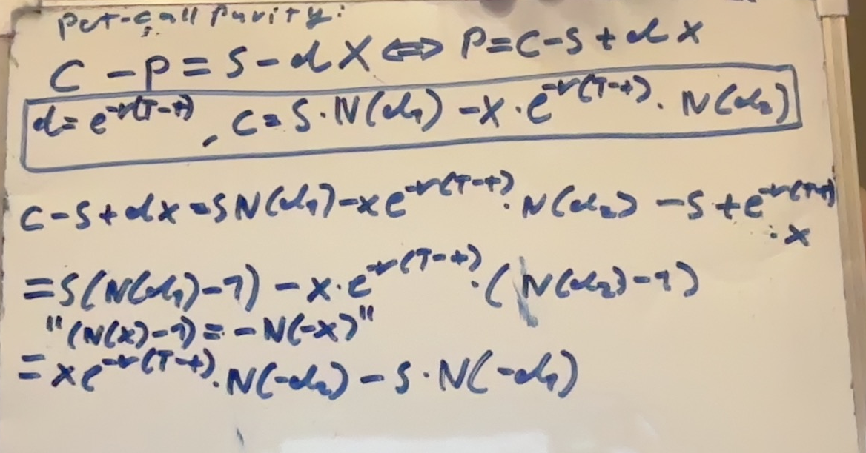

Exercise 4
Q1
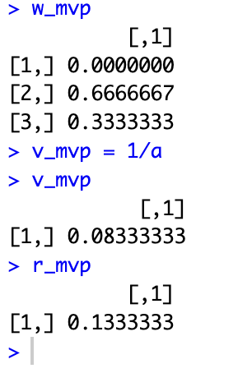
$$σ_{mvp}=\sqrt{0.083333}≈0,289$$

Q2
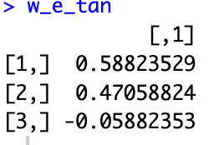

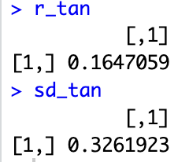

$$r_{tan}=0.165$$
$$σ_{tan}=0.326$$
Q3
We check if this point is under or above the line made from the risk free portfolio through the tangent portfolio
$$\overline{r_{p}}=r_{f}+\frac{r_{tan}-r_{f}}{σ_{tan}}·σ_{p}$$
$$0.02+\frac{0.165-0.02}{0.326}0.4≈0,198<0.2$$
Per the one fund theorem no portfolio can be above the line wreitten and thus it is impossible to get 20% expected return only allowing for a SD of 40%
Q4
$$r=\left(\begin{aligned}0.2 \\ 0.12 \\ 0.16\end{aligned}\right)+\left(\begin{matrix}2 & 1 \\ 0.5 & 1 \\ 0.7 & 1.4\end{matrix}\right)\left(\begin{aligned}F_{1} \\ F_{2}\end{aligned}\right)$$
From erlier we have
$$\overline{r}=\left(\begin{aligned}0.2 \\ 0.12 \\ 0.16\end{aligned}\right)$$
We note that $\overline{F_{1}}=\overline{F_{2}}=0$

We find the 2 portfolios and find the risk free one as a bonus
By simply solving some systems of equations
$$w_{1}=\left(\begin{matrix}1 & 1 & 0\end{matrix}\right){\left(\begin{matrix}1 & 2 & 1 \\ 1 & \frac{1}{2} & 1 \\ 1 & 0.7 & 1.4\end{matrix}\right)}^{-1}≈\left(\begin{matrix}0,667 & 2,833 & -2,5\end{matrix}\right)$$
$$w_{2}=\left(\begin{matrix}1 & 0 & 1\end{matrix}\right){\left(\begin{matrix}1 & 2 & 1 \\ 1 & \frac{1}{2} & 1 \\ 1 & 0.7 & 1.4\end{matrix}\right)}^{-1}≈\left(\begin{matrix}-0,333 & 1,333 & 0\end{matrix}\right)$$
$$w_{rf}=\left(\begin{matrix}1 & 0 & 0\end{matrix}\right){\left(\begin{matrix}1 & 2 & 1 \\ 1 & \frac{1}{2} & 1 \\ 1 & 0.7 & 1.4\end{matrix}\right)}^{-1}≈\left(\begin{matrix}0 & 3,5 & -2,5\end{matrix}\right)$$
$$\left(\begin{matrix}0 & 3,5 & -2,5\end{matrix}\right)\left(\begin{aligned}0.2 \\ 0.12 \\ 0.16\end{aligned}\right)≈0,02$$
Q5
We find the $λ's$
$${\left(\begin{matrix}1 & 2 & 1 \\ 1 & \frac{1}{2} & 1 \\ 1 & 0.7 & 1.4\end{matrix}\right)}^{-1}\left(\begin{aligned}0.2 \\ 0.12 \\ 0.16\end{aligned}\right)≈\left(\begin{matrix}0,02 \\ 0,053 \\ 0,073\end{matrix}\right)$$
$$λ_{1}=0.053$$
$$λ_{2}=0.073$$
Q6
We calculate the expected return in atp
$${\overline{r}}_{4}=λ_{0}+1.5·λ_{1}+λ_{2}=0.02+1.5·0.053+0.073≈0,172$$
Since both factors have mean 0 then $r_{4}$ is to high and there is an arbitrage opportunity explained in the next Question
Q7
We create a portfolio with the same factor exposure

$$\left(\begin{matrix}1 & 1.5 & 1\end{matrix}\right){\left(\begin{matrix}1 & 2 & 1 \\ 1 & \frac{1}{2} & 1 \\ 1 & 0.7 & 1.4\end{matrix}\right)}^{-1}≈\left(\begin{matrix}0,667 & 0,333 & 0\end{matrix}\right)$$
We create an asset by buying the new asset and selling in the market giving us the certain return
Sell the replcation and buy the new asset and leverage to infinity

$$0.18-0.172≈0,008$$

